

**Twin Peaks**

Speech given by Andrew G Haldane

Chief Economist Bank of England

Kenilworth Chamber of Trade Business Breakfast 17 October 2014

The views are not necessarily those of the Bank of England or the Monetary Policy Committee. I would like to thank Maria Barriel, Jeremy Franklin, Clare Macallan and Brad Speigner for assistance in preparing the text. I would also like to thank John Barrdear, Lucy Canham, Rob Elder, David Latto, Richard Harrison, Jeremy Harrison and Martin Weale for their comments and contributions.

Back in June, with the cricket season in full swing, my views on the appropriate stance for UK monetary policy were evenly-weighted between the front foot (moving rates sooner) and the back foot (moving them later). With the sun shining, meteorologically and economically, the evidence leaned slightly towards a front foot stance (Haldane (2014)).

Underpinning that judgement was the UK’s increasingly well-established and broadly- based economic recovery. Moving in a timely fashion to normalise rates helped avoid the risk of a hastier reaction later. In other words, it supported a limited and gradual subsequent path for interest rate rises.

Three months on, with temperatures falling and the football season in full swing, how do economic prospects now look? Has the financial weather changed? How have the economic batting averages evolved? And how has the appropriate monetary stance, back or front foot, been affected?

# Reasons to the Cheerful

In many respects, the UK’s recovery remains both strong and well-balanced. There are still plenty of reasons to be cheerful:

* Growth is running at an annual rate of over 3%, above its historical trend and at the top of the G7 league table. Growth in the UK will probably exceed global growth this year, for the first time in over a decade. According to outside and MPC forecasts, UK growth is expected to remain at or above trend for the next few years.
* Recent revisions to GDP suggest that the UK experienced both a shallower recession, and a somewhat stronger recovery, than previously believed. As a result, the level of GDP reached its pre-crisis peak in the middle of last year, three quarters sooner than earlier estimates suggested.
* UK growth is reasonably well-balanced between consumption and investment, although net trade continues to disappoint. Business investment is growing at double-digit rates and has contributed fully a third to economy-wide growth since its trough. According to the MPC’s forecasts, investment will continue to grow at double-digit rates in the period ahead.
* Consumer price inflation, at 1.2%, has fallen below the Bank of England’s 2% inflation target, reducing the squeeze on households’ real disposable incomes. According to financial markets, inflation is expected to return and stay close to target over the medium term.
* Borrowing costs remain at exceptionally low levels. Secured borrowing costs for households and large companies are in the range 3%-6%, around 3 percentage points lower than in 2007. Measures of credit conditions have continued to ease. According to the August *Inflation Repor*t forecasts, they will continue to ease in the period ahead.
* Asset prices have risen significantly, boosting economy-wide wealth. Since 2009, UK equity prices have risen by over 50%, UK ten-year government bond prices by around 15% and UK house prices by around 20%.1
* Perhaps most striking of all, employment in the UK has risen by almost 1.8 million since its trough and by around 750,000 in the past year alone. The unemployment rate has fallen from a peak of 8.4% to 6%. According to the August *Inflation Repor*t forecasts, it is expected to fall further in the period ahead, to close to 5%.

Economists since Arthur Okun have often combined macro-economic measures into a single index.2 It speaks volumes for economists’ psychological state that they tend to call these “misery indices”. Although something of a dog’s breakfast, misery indices provide a simple summary statistic of macro-economic health.

I have constructed an index of unemployment, inflation and GDP growth in the UK. The higher GDP growth, and the lower unemployment and inflation, the higher is the index and the healthier is assumed to be the economy. The choice of these measures, and their weighting, is rather arbitrary.3 To buck Thomas Carlyle’s image of the economist as dismal scientist, let’s call this an “ecstasy index”.

Chart 1 plots the ecstasy index for the UK since 1970. The index is currently about

6 percentage points above its average value over the period 1970-2014.4 As recently as 2009, it was around 2 percentage points below. The index has been above current levels in only 5 of the past 44 years. On this measure, the UK economy is in fine fettle.

The current reading of the index chimes pretty well with survey measures of confidence, for both households and firms. Measures of business confidence picked up during 2013

1 House prices are measured using the average of the Halifax and Nationwide indices.

2 Okun’s original misery index, which was also referred to as the ‘discomfort factor’, comprised unemployment and inflation.

3 Adding real wealth and/or real borrowing costs to the index does not alter the underlying trends.

4 The value for 2014 is an estimate based on projections consistent with the August 2014 *Inflation Report*.

and the first half of 2014 to reach series highs, while measures of consumer confidence rose above their long-run average levels at the start of 2014.

Chart 2 constructs the same ecstasy index back to 1870. It suggests that, while current levels of the index are less unusual, they are edging up towards historic highs. In only 42 of the past 144 years has the index been above current levels.

So far, then, so good. The UK economy appears to be healthier than on average in the past, if perhaps not quite yet ecstatic. Certainly, it appears to be firmly on the front foot.

# Reasons to be Fearful

In keeping with Thomas Carlyle’s stereotype, let me now add three flies to the ointment. These are features of the UK economy which paint a more sobering picture. In particular, let me offer three reasons to be fearful:

* Annual real wage growth in the UK – average weekly earnings growth adjusted for consumer price inflation – is currently running at close to minus 1%. Growth in real wages has been negative for all bar three of the past 74 months. The cumulative fall in real wages since their pre-recession peak is around 10%. As best we can tell, the length and depth of this fall is unprecedented since at least the mid-1800s (Table 1).
* Productivity – GDP per hour worked – was broadly unchanged in the year to 2014 Q2, leaving it around 15% below its pre-crisis trend level. The level of productivity is no higher than it was six years ago. This is the so-called “productivity puzzle”. Productivity has not flat-lined for that long in any period since the 1880s, other than following demobilisation after the World Wars.
* Annual real interest rates – for example, rates earned by households on time deposits adjusted for consumer price inflation – are around zero. They have been near-zero for close to four years. Real deposit rates have not been that low since the 1970s, when inflation was in double digits.

These indicators clearly have an important bearing on macro-economic health: among *workers* whose disposable incomes have fallen materially below their pre-crisis levels; among *savers*, the rates of return on whose assets have fallen materially below their pre- crisis levels and are near-zero in inflation-adjusted terms; and among *companies*, whose underlying efficiency has flat-lined since the crisis.

These trends are also closely linked. Weak productivity has constrained UK companies’ ability to pay higher wages, such that productivity and real wages have fallen in lockstep since 2008 (Chart 3). And this combination of a weak supply side and weak pricing pressures has in turn generated the need for low or negative real interest rates.

To give these developments some context, consider a simple index of real wages, real interest rates and productivity growth. Given their recent trends, and with an eye to semantic symmetry, let’s call this an “agony index”. Charts 4 and 5 plot this agony index from 1970 and back to 1870.

The agony index is currently at painfully low levels.5 It has been around 5 percentage points below its 1970-2014 average since 2008. Such an extended period of agony is virtually unprecedented going back to the late 1800s, with the exception of the aftermath of the World Wars and the early 1970s.

So far, then, so bad. On this evidence, the UK economy is as weak as at any time in the recent or distant past. It is firmly on the back foot. Rather peculiarly, the UK economy appears to be writhing in both agony and ecstasy. It is twin-peaked.

# Short-lived or Secular?

So which of these twin forces is likely to win out? This is an issue on which a global debate is currently raging. For some, the world is experiencing a fairly conventional recovery - perhaps slower and lower than usual, but with normal service resuming. For others, the world is instead facing a more protracted period of sub-par growth – an era of “secular stagnation” (Summers (2014)).

The MPC’s central view, as contained in its August *Inflation Report*, is a mix of the two views, but with a stronger flavour of the first. It envisages a slower and lower recovery than in the past, but which builds in momentum over time. For example, according to the *Inflation Report* projections, productivity and real wage growth are expected to enter positive territory during the first half of next year and real interest rates by 2016 (Chart 6).

Thereafter, all three are forecast to continue rising. By the end of 2017, productivity growth and real wage growth are back to around 2% and real household deposit rates are in positive territory (Chart 6). The agony index would then be back in line with its historical average. In other words, on the MPC’s central view the sun will come out tomorrow.

5 Again, the value for 2014 is an estimate based on projections consistent with the August 2014 *Inflation Report*.

The experience of past recessions supports this weather forecast. Chart 7 plots the path of real GDP following five UK recessions and subsequent recoveries: the 1930s, the 1970s, the 1980s, the 1990s and currently. The fall in GDP during this time’s crisis is little different than in the 1970s and 1980s and smaller than in the Great Depression.

The subsequent recovery in output has been materially slower than in the 1970s, 1980s and 1990s – and slower even than in the 1930s. As a result, the cumulative loss of output from this time’s crisis will very likely be larger than followed the Great Depression.

Nonetheless, once you allow for the longer lags, the growth in GDP over the past two years has not been greatly dissimilar to previous recoveries. And if you believe the MPC’s growth forecasts, that recovery is set to continue in the period ahead.

At a global level, the IMF’s recent *World Economic Outlook* paints a not dissimilar picture. Although global growth was revised down, it is expected to pick up from 3.3% this year to 3.8% next and 4.0% the year after. In other words, the IMF also foresees a slow march back to growth normality, albeit at potentially somewhat lower trend rates.

So why might this time be different? One illuminating piece of evidence comes from looking at how forecasts for real wages, productivity and real interest rates have evolved during the recovery. As one illustration, Charts 8 to 10 show *Inflation Report* forecast profiles for these three variables since 2008.

These suggest that the MPC, in common with every other mainstream forecaster, has been forecasting sunshine tomorrow in every year since 2008 – that is, rising real wages, productivity and real interest rates. The heat-wave has failed to materialise. The timing of the upturn has been repeatedly put back. Downside surprises have been correlated.

What is true in the UK is also true globally. In their most recent *World Economic Outlook*, the IMF evaluated their forecast performance since the crisis. This too points towards systematic, serially correlated, downside surprises to global growth since 2008.

Of course, this is evidence from the past not the future. Are there reasons to believe these surprises might persist into the future? Financial market prices can provide some guide, in particular about the likely future path of real interest rates.

Chart 11 plots how global real interest rates have evolved since 1970. It exhibits a secular downward trend which long precedes the crisis, suggesting global desired savings rates

outstripped global desired investment rates. Pre-crisis explanations for this trend included a “glut” of savings in the East and “excess” consumption in the West (King (2011)).

Whatever the cause, the crisis resulted in a further lurch down in global real rates, with precautionary savings rising and investment intentions falling. More strikingly still, there has been the further marked fall in global real rates during the course of this year. Five- year real interest rates expected in five years’ time have fallen by over 100 basis points in the United Kingdom, the euro area and the United States (Chart 12).

The upshot is a fascinating pattern of real interest rates along the yield curve (Chart 13). In the UK, real interest rates are now expected to remain *negative* for at least the next 40 years. The pattern is less dramatic in the US and euro-area, but even there real rates remain at exceptionally low levels as far as the eye can see.6

That is truly extra-ordinary and naturally begs the question - why? One hypothesis is that it simply reflects a portfolio shift by investors towards government assets – if you like, a “search for safety” in the face of heightened geo-political risks. The implications for future growth might then be relatively benign, either because these risks are short-lived or because they do not affect companies’ investment plans. In other words, the pattern of real rates might still be consistent with a recovery.

An alternative hypothesis is that these developments reflect pessimistic expectations about future growth prospects, which are mirrored in expected policy rates needing to remain lower for much longer. This would carry more far-reaching and negative implications for the economy, more in line with the secular stagnation hypothesis.

# A Tale of Two Workers

So which of the twin-peaked outcomes facing the economy is most likely? An imminent burst of macro-economic sunshine? Or leaden-grey skies as far as the eye can see?

Several factors have been put forward to support the secular stagnation hypothesis. They include rising levels of inequality, worsening levels of educational attainment, a rising debt overhang, lower prices for investment goods, rising levels of youth unemployment and lower levels of innovation (Gordon (2012), VoxEU (2014)). None should be dismissed lightly.

6 The levels of these international series are not entirely comparable, as UK real rates are indexed to RPI, whereas US and European are indexed to CPI.

But nor do these factors necessarily contradict the possibility of recovery in at least some parts of the economy. It is entirely possible that both poles may be in play – if you like, sunshine with showers - pulling the economy in opposing directions. Those polarising forces are well illustrated by developments in the labour market.

Polarisation in the labour market has been a phenomenon since at least the 1980s, with a “hollowing out” of employment across the skill-distribution (Goos and Manning (2007) Goos *et al* (2009), Autor *et al* (2003, 2006, 2010), Sissons (2011), McIntosh (2013), Plunkett and Pessoa (2013)). Employment growth has been strongest among the highest and lowest-skilled. But the casualty has been the mid-skilled, where employment has fallen.

This structural shift is usually attributed to technological displacement of mid-skill jobs – for example, because of the automation and digitisation of certain tasks. For that reason, a “smiley face” employment pattern has been found across a wide number of countries when looked at in skills space. This is shown for the UK in Chart 14.

The crisis has tended to reinforce these trends. Unemployment among the highly-skilled rose less during the crisis (Chart 15). With employment growth strong (Chart 14), unemployment within the highly-skilled sectors has returned to close to pre-crisis levels.

By contrast, unemployment rates among the mid-skilled rose by more during the crisis (Chart 15). In keeping with pre-crisis trends, employment has contracted (Chart 14). Meanwhile, for the lowest skilled the picture is more nuanced. While suffering most during the crisis, they have also benefitted from rapid rises in employment during the recovery (Chart 14).

In principle, these patterns of employment ought to have been reflected in real wages. We might expect wages to have risen at either end of the skill distribution, but potentially to have stalled for the mid-skilled. There would have been a “hollowing out” of wages, but the aggregate wage distribution ought to have been relatively static.

In practice, the distribution of wages has not been static; it has widened over the past 20 years (Chart 16). In the late 1990s, wages for the top 10% of earners were around 6.5 times higher than the bottom 10%. Today, the figure is closer to eight. Or, put differently, in the decade prior to the recession, real wages for the top decile rose on average by 3% per year, while for the bottom decile they rose by around half that.

Since the crisis, there has been an across-the-board squeeze on real wages (Gregg *et al* (2014)). Those distributional differences have, however, persisted and have if anything widened further. Despite having fallen by almost 10% since the crisis, real wages among the top 10% are still over 20% higher than in 1997. But wages for the bottom 20% have fallen by almost 20% since 2007 and are essentially back to where they were in 1997.7

These polarising forces in the labour market are also evident across industries (Chart 17). Between 2001 and 2007, median annual wage growth across industries was 4% with a standard deviation of 1 percentage point. During 2014, average real wage growth has averaged 1% with a standard deviation of 2.5 percentage points (Chart 18). Wage dispersion has risen markedly. In some sectors wages are growing faster than before the crisis, while in others they are falling in both real and nominal terms.

So while strong employment demand has helped sustain wages among the highly-skilled, it has not worked the same magic for the lower skilled. That begs the question - why?

The most likely explanation is that rising demand has been more than offset by the rise in the *supply* of labour for these services. Several factors are likely to have been at play.

First, displaced mid-skilled workers may have sought jobs for which they are over-qualified in order to stay in employment. In other words, they have moved down the skill distribution, placing downward pressure on wages. The crisis is likely to have reinforced these trends.

Second, participation rates within the labour force have increased significantly, both prior to the crisis and over the past couple of years, especially among women and older age cohorts. This reflects a range of factors including the abolition of the default retirement age, concerns about the adequacy of pension and saving income and changes to the benefits regime.

Third, levels of immigration have increased significantly over the past 20 years, boosting labour supply. There is an active debate on its effects on the wage distribution. For example, Dustmann *et al* (2013) find that each 1% increase in the share of migrants in the working age population leads to a 0.6% decline in the wages of the 5% lowest-paid workers. Several studies report similar results (Migration Advisory Committee (2012)).

7 Part of the weakness in earnings at the bottom of the distribution is likely to be due to a compositional shift to part-time employment. However, even controlling for this shift, the wage distribution has still widened significantly over this period.

At a headline level, these polarising patterns are also clear in aggregate wage data. According to contacts of the Bank’s Agents, staff shortages are rising in highly-skilled professions such as IT, engineering and construction. Furthermore, the Recruitment & Employment Confederation (REC) survey suggests that the annual rate of wage inflation for new hires is now above 4% (Chart 19).

But measures of economy-wide average weekly earnings (AWE) paint an altogether different picture. Annual rates of wage inflation are currently around 0.7%, below the rate of inflation. Put differently, the jaws between the wage growth of the highly-skilled and the rest of the economy are wide and have widened. If the self-employed were added to the mix, whose wage levels are on average lower, those jaws would be wider still (Gardiner (2014)).

Taken together, this paints a picture of a widening distribution of fortunes across the labour market – a Tale of Two Workers. The upper peak of the labour market is clearly thriving in both employment and wage terms. The mid-tier is languishing in both employment and real wage terms. And for the lower skilled, employment is up at the cost of lower real wages for the group as a whole. This has been a jobs-rich, but pay-poor, recovery.

What is true among workers is also evident among companies (Barnett *et al* (2014a, 2014b)). There is evidence of a widening distribution of performance across companies and sectors. Since the crisis, the distribution of productivity across sectors has widened more than fourfold (Chart 20). And while productivity among the best-performing firms has held up, for others it has fallen like a stone (Chart 21).

If this story of a growing, but diverging, economy is right, then the message is clear. Forecasts of both macro-economic sunshine and showers, tales of both agony and ecstasy, sightings of both the upper and lower peaks, may be here for some time to come.

# Monetary Policy Implications

A bi-modal distribution for the economy poses a particular challenge for monetary policy. It can only affect average outcomes in the economy. Should policy tighten in anticipation of tomorrow’s sunshine for some? Or remain loose fearing tomorrow’s rain for others?

To illustrate those dilemmas, consider some very simple and mechanical settings for monetary policy as given by a Taylor rule (Taylor (1993)). The simplest of the Taylor rules takes the form:

𝑖𝑡 − 𝜋𝑡 = 𝑟∗ + 𝜃𝜋(𝜋𝑡 − 𝜋∗ ) + 𝜃𝑦(𝑦𝑡 − 𝑦̂𝑡)

𝑡

In other words, the real policy rate (it – πt) deviates from its equilibrium rate (r*t) to the extent that inflation (πt) deviates from its target (π*) and output (yt) from its trend (ŷt). In Taylor’s original work, the feedback parameters, 𝜃𝜋 and 𝜃𝑦, were both set at 0.5 and r* at

2%, in line with its historic average.

If we plug measures of inflation and the output gap into equation (1), both historically and using the MPC’s forecasts for the future, we generate the Taylor-rule implied paths shown in Chart 22. Also shown is the path of actual and (looking forward) market-implied policy interest rates at the time of the August 2014 *Inflation Report*.

Both in the years running up to the crisis, and in the initial crisis stages, these paths roughly coincided. Policy was broadly on its Taylor rule-implied path. Since around 2010, however, the two paths have parted company. On the Taylor rule path, monetary policy would have begun tightening at the end of 2009 and interest rates would be fully

2½ percentage points higher today.

Taken at face value, this implied trajectory poses a challenge to current policy settings. If this was a business-as-usual recovery, with equilibrium real rates close to historical levels, the Taylor-rule would suggest a considerably more aggressive monetary policy response, and a tighter stance, than has been the case in practice.8

Of course, there are good reasons for believing this may not be a business-as-usual recovery. For one thing, medium-term real rates of interest are materially lower than in the past (Chart 12). If these expectations were to be mirrored in persistently lower growth rates in the economy, then that would imply a lower equilibrium real rate of interest.9

Assume that equilibrium real interest rates are not fixed at 2%, but move in line with the real forward rate curve shown in Chart 13. That would give the Taylor rule path shown in Chart 23. This is now consistently below the actual and market-implied path. In other

8 An important reason why the Taylor rule points to tighter policy over this period is that the United Kingdom was hit by a series of large relative price shocks – increases in import prices (stemming from both the depreciation of sterling and rises in commodity and world export prices), increases in energy price, and changes to the rate of VAT – that raised CPI inflation. It is not obvious that tightening monetary policy in line with the prescription from the Taylor rule in order to offset these shocks would have been desirable.

9 By contrast, if the effect on supply capacity was only temporary, lowering the measured output gap, that could imply the need for *tighter* policy.

words, if secular stagnation is the name of the game, the Taylor rule suggests interest rates could remain lower for longer than markets currently expect.

So how should a policy-maker choose between these twin peaks and their implied paths? The optimal response could be to probability-weight the two peaks, updating the probabilities as new data arrives. Financial markets may be doing just that. Implied interest rates lie between the upper peak recovery of Chart 22 and the lower peak of Chart

23. Markets rates have coursed a path in the valley between the twin peaks.

But this path is also shifting towards the lower peak. Over the past few months, the implied path for interest rates in the UK and globally has shifted down. In the UK, forward interest rates at the end of 2017 have shifted down by 80bp since the middle of the year, to stand below 1.7%. One interpretation of that move is the market is now assigning a somewhat higher probability to the lower peak.

Whether this is the optimal – or indeed even the most likely – path for interest rates is a different issue. For example, if there is genuine uncertainty about the path of the economy, the optimal policy response may be to avoid the worst outcomes – in other words, to set policy to avoid the lower peak. That might imply a path for rates closer to Chart 23.

# Conclusion

In June, when evaluating the UK’s monetary stance, I used the metaphor of a batsmen in cricket deciding whether to play off the front foot (raise rates) or the back foot (hold rates). And I compared the averages of two English batsmen, one who played from the front foot (Ian Bell), the other from the back (Joe Root), to illustrate the dilemma.

At the time, Ian Bell averaged 45 to Joe Root’s 43. In other words, while it was a close run thing, the data narrowly favoured the front foot. Cricketing statistics are not the sole basis for my views on the appropriate stance for UK monetary policy. Nonetheless, on balance, I felt the same front-foot judgement was appropriate for UK interest rates at the time.

Three months on, it is time to update the batting averages. Ian Bell’s batting average has remained at 45 – the front foot recovery has remained on track. But over the same period, Joe Root’s has risen to 51. Cricket statisticians and financial markets are agreed. While still a close run thing, the statistics now appear to favour the back foot.

On balance, my judgement on the macro-economy has shifted the same way. I have tended to view the economy through a bi-modal lens. And recent evidence, in the UK and globally, has shifted my probability distribution towards the lower tail. Put in rather plainer English, I am gloomier.

That reflects the mark-down in global growth, heightened geo-political and financial risks and the weak pipeline of inflationary pressures from wages internally and commodity prices externally. Taken together, this implies interest rates could remain lower for longer, certainly than I had expected three months ago, without endangering the inflation target.

Thank you.

# Appendix

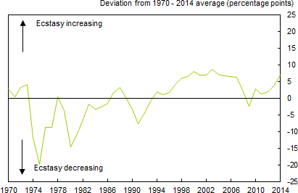**Chart 1:** Ecstasy Index, 1970 to present

Sources: Broadberry and van Leeuwen (2010), Feinstein (1972), Mitchell (1988), Sefton and Weale (1995), Solomou and Weale (1991), ONS and Bank calculations. Notes: The ecstasy index is calculated as annual GDP growth less the unemployment and inflation rates. Unemployment is the claimant count measure. The value for 2014 is an estimate based on projections consistent with the August 2014 *Inflation Report*. For more information on the long-run data used to construct this index, see Dimsdale, N, Hills, S and Thomas, R ‘The UK recession in context – what do three centuries of data tell us?’, Bank of England Quarterly Bulletin Vol. 50, No. 4, pp. 277-91. Standard deviation over this period is 6.5pp.

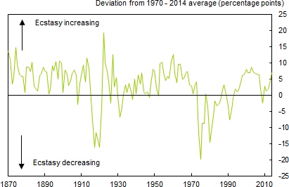**Chart 2:** Ecstasy Index, 1870 to present

Sources: Broadberry and van Leeuwen (2010) , Feinstein (1972), Mitchell (1988), Sefton and Weale (1995), Solomou and Weale (1991), ONS and Bank calculations. See the notes to Chart 1 for more information. Standard deviation over this period is 6.4pp.

**Table 1:** Comparison of periods of significant falls in real wages

|  |  |  |  |  |  |
| --- | --- | --- | --- | --- | --- |
|  | **1865-67** | **1874-78** | **1921-23** | **1976-77** | **2007-14** |
| Duration (years) | 2 | 4 | 2 | 2 | 7 |
| Depth (%) | -10 | -1.7 | -8.2 | -6.6 | -8.2 |
| Recovery (%) | 12.8 | 0.6 | 4.5 | 14.5 | n.a. |
| Total change over seven years (%) | 1.2 | -1.1 | -4.0 | 6.9 | -8.2 |

Source: Trade Union Congress. Notes: taken from ‘UK workers suffering the most severe squeeze in real earnings since Victorian times’, Labour Market and Economic report, available at [http://www.tuc.org.uk/economic-issues/labour-market-and-economic-](http://www.tuc.org.uk/economic-issues/labour-market-and-economic-reports/economic-analysis/britain-needs-pay-rise/uk) [reports/economic-analysis/britain-needs-pay-rise/uk.](http://www.tuc.org.uk/economic-issues/labour-market-and-economic-reports/economic-analysis/britain-needs-pay-rise/uk)

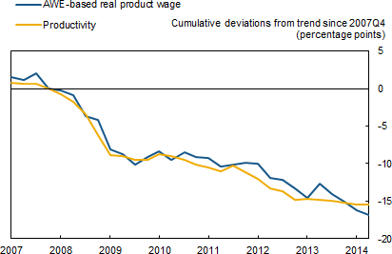**Chart 3:** Private sector productivity and real wages

Sources: ONS and Bank calculations. Notes: Trend productivity is calculated using the average growth rate between 1997 Q1 and 2007 Q4. The blue line is calculated based on Average Weekly Earnings (AWE) deflated using the GDP deflator.

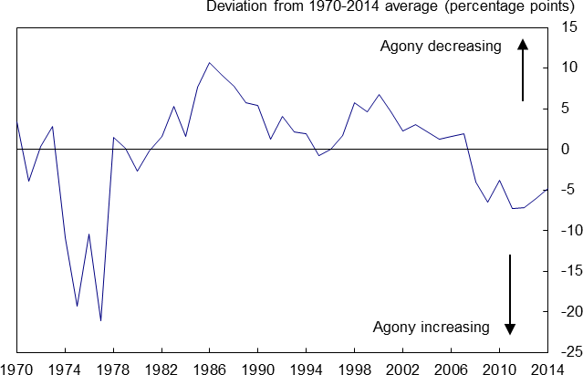**Chart 4:** Agony Index, 1970 to present

Sources: Broadberry and van Leeuwen (2010), Crafts and Mills ( 1994), Feinstein (1972), Mitchell (1988), Sefton and Weale (1995), Solomou and Weale (1991),ONS and Bank calculations. Notes: The agony index is calculated as annual productivity growth, annual real wage growth and the real household time deposit rate. Productivity is measured as GDP per hour worked. The value for 2014 is an estimate based on projections consistent with the August 2014 *Inflation Report*. For more information on the long-run data used to construct this index, see Dimsdale, N, Hills, S and Thomas, R ‘The UK recession in context – what do three centuries of data tell us?’, *Bank of England Quarterly Bulletin* Vol. 50, No. 4, pp. 277-91. Standard deviation over this period is 6.6pp.

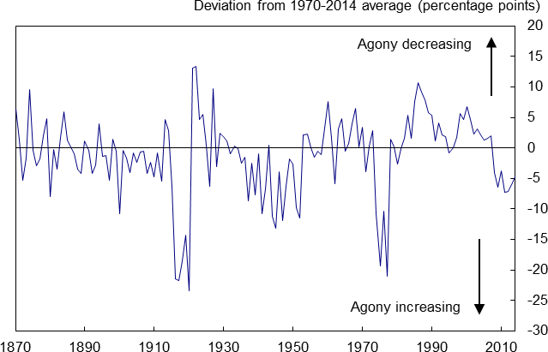**Chart 5:** Agony Index, 1870 to present

Sources: Broadberry and van Leeuwen (2010), Crafts and Mills ( 1994), Feinstein (1972), Mitchell (1988), Sefton and Weale (1995), Solomou and Weale (1991),ONS and Bank calculations. See the notes to Chart 4 for more information. Standard deviation over this period is 6.6pp.

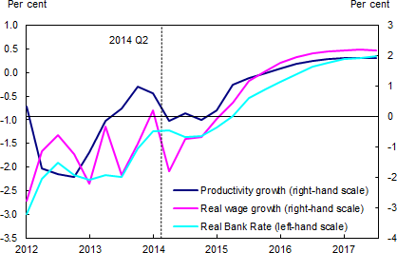**Chart 6:** August Inflation Report projections for productivity and real wages and the path for real Bank Rate consistent with the market-implied conditioning path for interest rates

Sources: ONS and projections consistent with MPC key judgements in the August 2014 Inflation Report. Notes: Productivity is measured as GDP per hour worked.

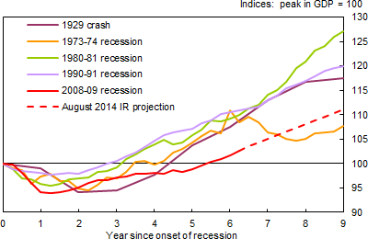**Chart 7:** Path of real GDP in recovery periods after recessions

Sources: Broadberry and van Leeuwen (2010), Mitchell (1988), Sefton and Weale (1995), Solomou and Weale (1991),ONS and Bank calculations. Notes: data are quarterly except for the 1929, which uses annual data.

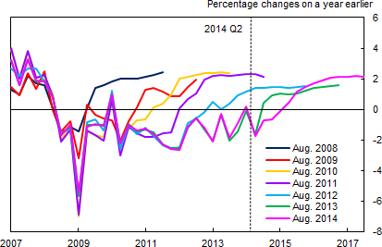**Chart 8:** Bank of England *Inflation Report* projections for real wages

Sources: ONS and projections consistent with MPC judgements in the August Inflation Reports. Notes: The measure of wages used is the Average Earnings Index for projections made in August 2008 and August 2009, and average weekly earnings for projections made from August 2010 onwards. Real wages are deflated using annual CPI inflation.

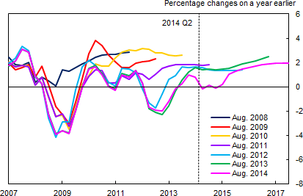**Chart 9:** Bank of England *Inflation Report* projections for productivity

Sources: ONS and projections consistent with MPC judgements in the August *Inflation Reports*. Notes: Productivity is measured as GDP per hour worked. GDP is measured using the MPC’s backcast.

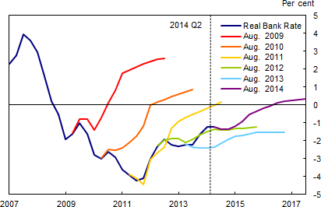**Chart 10:** Bank of England *Inflation Report* projections for the path for real Bank Rate consistent with the market-implied conditioning path for interest rates

Sources: Bank of England, ONS and Bank of England August *Inflation Reports*.

**Chart 11:** Global real interest rates

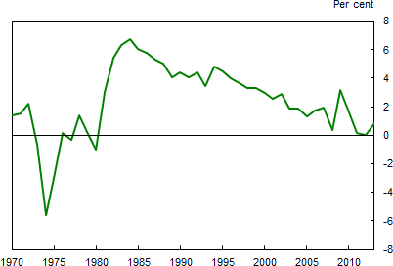

Sources: IMF and Bank Calculations. Notes: This is an ex post measure of the long-run global real interest rate, estimated as the difference between 10-year nominal government bond yields and current annual CPI inflation outturns for the G7 countries (Canada, France, Germany, Italy, Japan, UK and US), weighted together using PPP weights. Data for Italy only available from 1972, for Germany from 1978.

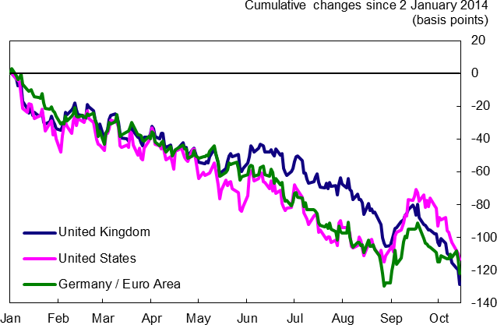**Chart 12:** Five-year real interest rates, five years forward

Sources: Bloomberg and Bank calculations. Notes: Data for the United Kingdom and the United States are derived from five-year, five year forward nominal bond yields deflated using inflation swaps. The Germany/EA figures show the five-year, five year forward nominal Bund yield deflated using euro-area inflation swaps (as a proxy for the euro-area risk free rate). The measure of inflation used is RPI for the United Kingdom and CPI for the United States and the euro area. Data are to close of business 15 October 2014.

**Chart 13:** Forward real interest rate yield curves

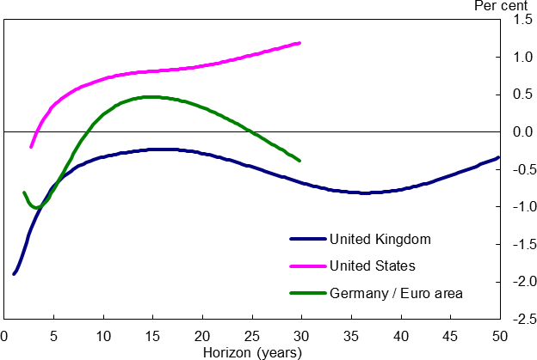

Sources: Bloomberg and Bank calculations. Notes: Data for the United Kingdom and the United States are derived from nominal bond yields deflated using inflation swaps. The Germany/EA figures are based on nominal Bund yield deflated using euro-area inflation swaps (as a proxy for the euro-area risk free rate). The measure of inflation used is RPI for the United Kingdom and CPI for the United States and the euro area. Data are to close of business 15 October 2014.

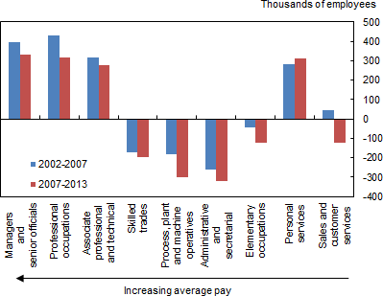**Chart 14:** Change in number of employees by occupation

Sources: Labour Force Survey and Bank calculations. Notes: Occupations are ordered according to the level of median hourly pay in 2006 (taken from the Annual Survey of Earnings and Hours) as a proxy of average skill.

**Chart 15:** Unemployment rates by previous occupation

Per cent

5

High Skill

Medium Skill Low skill

4

3

2

1

0

-1

Jun-01 Jun-03 Jun-05 Jun-07 Jun-09 Jun-11 Jun-13

Sources: Labour Force Survey and Bank calculations. Notes: Blue denotes high skill occupation; orange denotes medium skill; and green denotes low skill occupations ranked by the level of median hourly pay in 2002.

**Chart 16:** The distribution of private sector real wages since 1997

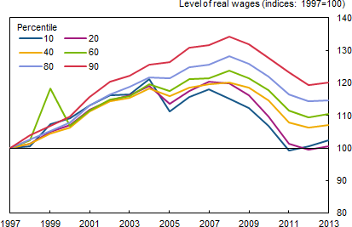

Sources: ONS Annual Survey of Earnings and Hours and Bank calculations. Notes: The chart shows the level of private sector real wages across all employees in 1997 prices (deflated using the CPI index).

**Chart 17:** The distribution of average annual wage growth across industries between 2001 and 2007

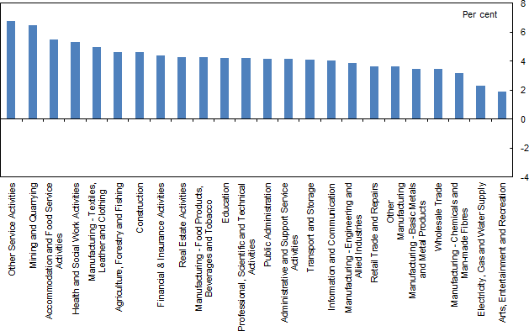

Sources: Labour Force Survey and Bank calculations. Notes: The measure of wages used is average weekly earnings excluding bonuses.

**Chart 18:** The distribution of average annual wage growth across industries in 2014

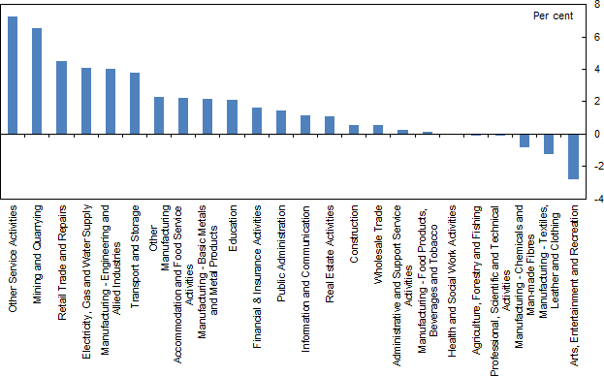

Sources: Labour Force Survey and Bank calculations. Notes: The measure of wages used is average weekly earnings excluding bonuses.

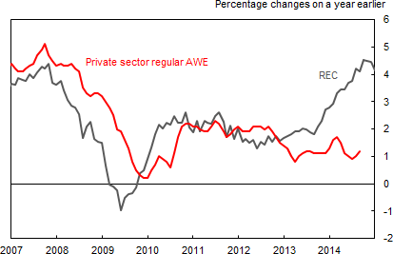**Chart 19:** Annual private sector wage growth

Sources: ONS (including the Labour Force Survey) and KPMG/REC/Markit. Notes: AWE is Average Weekly Earnings measured by the ONS. REC is a survey measure based on information from recruitment consultants. The REC measure is the indices for permanent and temporary placements, weighted together using shares in employment and moved forward 3 months.

**Chart 20:** Productivity dispersion across industries

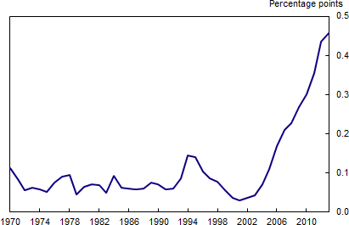

Sources: EUKlems, ONS, and Bank calculations. Notes: the chart shows the standard deviation of productivity differentials (relative to a trend calculated between 1970 and 2006) across 1 digit SIC sectors.

**Chart 21:** Productivity dispersion across industries, 1970 to 2013

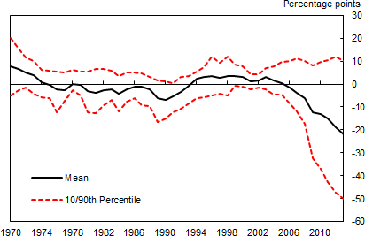

Sources: EUKlems, ONS and Bank calculations. Notes: the chart shows productivity differentials (relative to a trend calculated between 1970 and 2006) across 1 digit SIC sectors

**Chart 22:** Simple Taylor-rule implied paths for Bank rate with equilibrium real interest rates at 2%

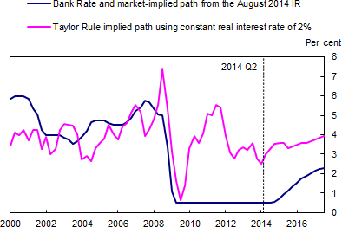

Sources: Bank of England, ONS, projections consistent with MPC judgements in the August Inflation Reports and Bank calculations.

**Chart 23:** Simple Taylor-rule implied paths for Bank rate with equilibrium real interest rates in line with market real interest rates

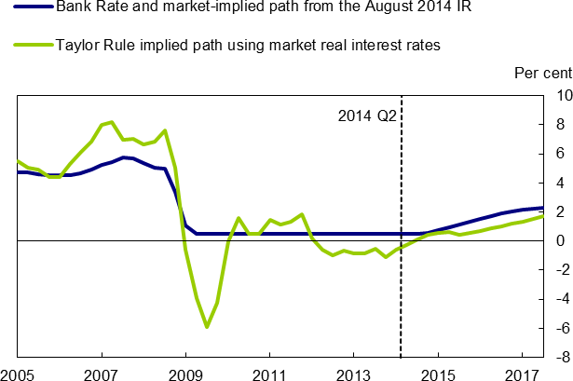

Sources: Bank of England, Bloomberg, ONS, projections consistent with MPC judgements in the August Inflation Reports and Bank calculations. Data for market real interest rates (used in the green line) are to close of business 15 October 2014 and are derived from nominal bond yields deflated using inflation swaps. An adjustment is made to account for the difference between RPI and CPI.

# References

**Acemoglu, D and Autor, D H (2010)**, ‘Skills, tasks and technology: Implications for employment and earnings’, *NBER Working Paper No. 16082*, National Bureau of Economic Research, Cambridge, MA.

**Autor, D H, Katz, L F and Kearney, M S (2006)**, ‘The polarization of the US labor market’,

*American Economic Review: Papers and Proceedings*, Vol. 96, No. 2, pp. 189–94.

**Autor, D, Levy, F and Murnane, RJ (2003)**, ‘The skill content of recent technological change: An empirical exploration’, *Quarterly Journal of Economics*, Vol. 118, No. 4, pp. 1279–1333.

**Bank of England (2014)**, ‘August 2014 *Inflation Report’*, available at <http://www.bankofengland.co.uk/publications/Pages/inflationreport/2014/ir1403.aspx>.

**Barnett, A, Batten, S, Chiu, A, Franklin, J and Sebastiá-Barriel, M (2014a)**, ‘The UK productivity puzzle’, *Bank of England Quarterly Bulletin*, Vol. 54, No.2, pages 114-28, available at <http://www.bankofengland.co.uk/publications/Pages/quarterlybulletin/2014/qb14q2.asp>.

**Barnett, A, Broadbent, B, Chiu, A, Franklin, J and Miller, H** (2014b), ‘Impaired capital reallocation and productivity’ *National Institute Economic Review*, No. 228, 2014.

**Dustmann, C, Frattini, T, and Preston, I (2013),** ‘The Effect of Immigration along the Distribution of Wages’, *Review of Economic Studies*, Vol. 80, No. 1, pp. 145-73.

**Gardiner, L (2014)**, ‘All accounted for: The case for an ‘all-worker’ earnings measure’, Resolution Foundation Briefing.

**Goos, M and Manning, A (2007)**, ‘Lousy and lovely jobs: The rising polarisation of work in Britain’, *Review of Economics and Statistics*, Vol. 89, No. 1, pp. 118–33.

**Goos, M, Manning, A and Salomons, A (2009),** ‘Job polarization in Europe’, *American Economic Review: Papers and Proceedings*, Vol. 99, No. 2, pp. 58–63.

**Gordon, R (2012)**, ‘Is US economic growth over? Faltering innovation confronts the six headwinds’, *NBER Working Paper 18315*, available at: <http://www.nber.org/papers/w18315.pdf>

**Gregg, P, Machin, S, Fernandez-Salgado, M (2014)**, ‘The squeeze on real wages – and what it might take to end it’, *National Institute Economic Review*, No. 228, 2014.

**Haldane, A G (2014),** ‘The corridor of uncertainty’, speech at the Scarborough Business Ambassadors’ dinner, 18 June 2014, available at <http://www.bankofengland.co.uk/publications/Pages/speeches/2014/738.aspx>.

**IMF (2014)**, ‘Legacies, Clouds, Uncertainties’, *World Economic Outlook* October 2014, available at:

<http://www.imf.org/external/pubs/ft/weo/2014/02/>

**King, M (2011)**, ‘Global imbalances: the perspective of the Bank of England’, *Banque de France Financial Stability Review*, available at: <http://www.nber.org/papers/w19887.pdf>

**Migration Advisory Committee (2012)**, ‘Analysis of the Impacts of Migration’, *Migration Advisory Committee.* Available at: [https://www.gov.uk/government/uploads/system/uploads/attachment_data/file/257235/anal](https://www.gov.uk/government/uploads/system/uploads/attachment_data/file/257235/analysis-of-the-impacts.pdf) [ysis-of-the-impacts.pdf](https://www.gov.uk/government/uploads/system/uploads/attachment_data/file/257235/analysis-of-the-impacts.pdf)

**McIntosh, S (2013)**, ‘Hollowing out and the future of the labour market’, BIS Research Paper Number 134, available at: [https://www.gov.uk/government/uploads/system/uploads/attachment_data/file/250206/bis-](https://www.gov.uk/government/uploads/system/uploads/attachment_data/file/250206/bis-13-1213-hollowing-out-and-future-of-the-labour-market.pdf) [13-1213-hollowing-out-and-future-of-the-labour-market.pdf](https://www.gov.uk/government/uploads/system/uploads/attachment_data/file/250206/bis-13-1213-hollowing-out-and-future-of-the-labour-market.pdf)

**Plunkett, J and Pessoa, J P (2013)**, ‘A Polarising Crisis? The changing shape of the UK and US labour markets from 2008 to 2012’, Resolution Foundation Briefing.

**Sissons, P (2011)**, ‘The hourglass and the escalator: labour market change and mobility’, The Work Foundation. Available at: [http://www.theworkfoundation.com/DownloadPublication/Report/292_hourglass_escalator](http://www.theworkfoundation.com/DownloadPublication/Report/292_hourglass_escalator120711%20(2)%20(3).pdf) [120711%20(2)%20(3).pdf](http://www.theworkfoundation.com/DownloadPublication/Report/292_hourglass_escalator120711%20(2)%20(3).pdf)

**Summers, L (2014)**, ‘U.S. economic prospects: secular stagnation, hysteresis, and the zero lower bound’, Keynote address at the NABE Policy Conference, 24 February 2014, printed in *Business Economics*, Vol. 49, No.2, pp 65-73.

**Taylor, J (1993) ‘**Discretion versus Policy Rules in Practice’, *Carnegie-Rochester Conference Series on Public Policy*, Vol. 39, pp. 195-214.

**Trade Union Congress (2014)**, ‘UK workers suffering the most severe squeeze in real earnings since Victorian times’, Labour Market and Economic report, available at [http://www.tuc.org.uk/economic-issues/labour-market-and-economic-reports/economic-](http://www.tuc.org.uk/economic-issues/labour-market-and-economic-reports/economic-analysis/britain-needs-pay-rise/uk) [analysis/britain-needs-pay-rise/uk](http://www.tuc.org.uk/economic-issues/labour-market-and-economic-reports/economic-analysis/britain-needs-pay-rise/uk).

**VoxEU (2014),** ‘Secular stagnation: facts, causes and cures’, VoxEU eBook available at: <http://www.voxeu.org/sites/default/files/Vox_secular_stagnation.pdf>

**Weale, M (2014),** ‘Slack and the labour market’, *speech at the Thames Valley Chamber of Commerce, 20 March 2014*, available at <http://www.bankofengland.co.uk/publications/Documents/speeches/2014/speech716.pdf>.